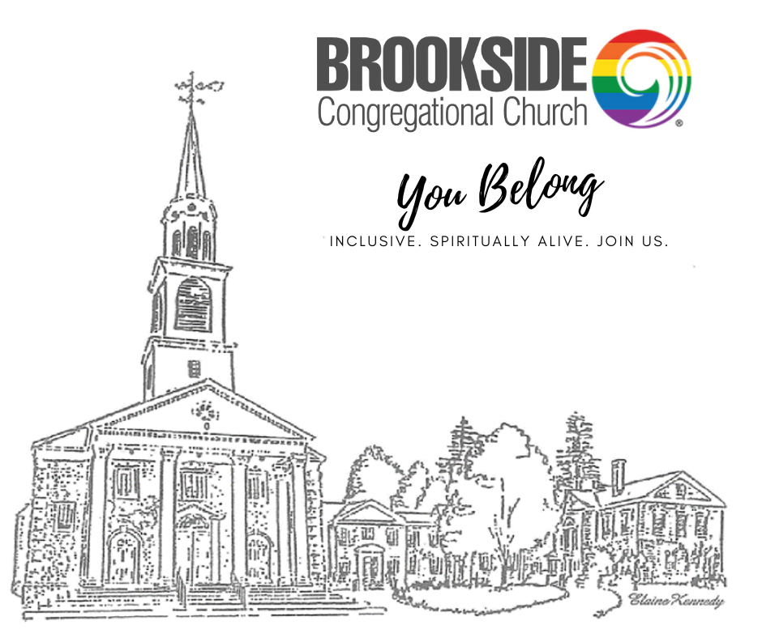

**October 1, 2023 – 10:00 AM**

**Eighteenth Sunday after Pentecost**

Rev. Laura Biddle, Minister

Kim and Ken Clark, Music Directors

Louise Popp, Church Administrator

*An Open and Affirming Congregation*

2013 Elm Street, Manchester, NH 03104-2528

Tel. (603) 669-2807 ~ Fax (603) 668-9041

admin@brookside.org ~ www.brooksidecc.org

Balcony seating is available to those wishing a more private worship experience.

Children go directly to Spiritual Art.

*Please Stand

ANNOUNCEMENTS

The **flowers** this morning are given in loving memory of Hope Pearson by Sarah and Bob Merrill and Carl Pearson.

PRELUDE

GREETING

CALL TO WORSHIP

Leader: Come, let us remember God’s presence with us. Let us give ear to all that God would teach us.

**People: Let us celebrate God’s wondrous deeds and break bread with Jesus Christ.**

Leader :Come with your questions and doubts. We all need assurance that God is always with us.

**People: God is the essence of our collective voices. Whether in silence or in prayer, God is with us in word and deed.**

Leader: Let us be the church that worships God whole heartedly.

INTROIT *Spirit of the Living God* Brookside Singers

PRAYER OF CONFESSION

WORDS OF AFFIRMATION

*HYMN  *The Church’s One Foundation* N 386

SCRIPTURE Matthew 21:23-32 Jane Sherwin When he entered the temple, the chief priests and the elders of the people came to him as he was teaching, and said, “By what authority are you doing these things, and who gave you this authority?” Jesus said to them, “I will also ask you one question; if you tell me the answer, then I will also tell you by what authority I do these things. Did the baptism of John come from heaven, or was it of human origin?” And they argued with one another, “If we say, ‘From heaven,’ he will say to us, ‘Why then did you not believe him?’ But if we say, ‘Of human origin,’ we are afraid of the crowd; for all regard John as a prophet.” So they answered Jesus, “We do not know.” And he said to them, “Neither will I tell you by what authority I am doing these things. “What do you think? A man had two sons; he went to the first and said, ‘Son, go and work in the vineyard today.’ He answered, ‘I will not’; but later he changed his mind and went. The father went to the second and said the same; and he answered, ‘I go, sir’; but he did not go. Which of the two did the will of his father?” They said, “The first.” Jesus said to them, “Truly I tell you, the tax collectors and the prostitutes are going into the kingdom of God ahead of you. For John came to you in the way of righteousness and you did not believe him, but the tax collectors and the prostitutes believed him; and even after you saw it, you did not change your minds and believe him.

SERMON By What Authority? Rev. Laura

ANTHEM At the Table; Clark Brookside Singers

OFFERTORY

*DOXOLOGY

**Praise God from whom all blessings flow;**

**Praise God, all creatures here below;**

**Praise God for all that love has done:**

**Creator, Christ, and Spirit One.**

# the sacrament of holy communion (in the round)

INVITATION

COMMUNION PRAYER LORD’S PRAYER – DEBTS AND TRESPASSES

SHARING OF THE BREAD AND THE CUP

PRAYER OF THANKSGIVING

*HYMN *What Wondrous Love is This* N 223

BENEDICTION

POSTLUDE *When the Saints go Marching In; American Traditional*

Deacon of the Week: Christina Alvarez

Reader: Jane Sherwin

Spirit Squad: Alvarez Family

Livestream Driver: Dale Trombley

Please Remember in Prayer

Ruth Bodge Anne Lachance

Judith Chiasson Ellen Little

Thomas and Julie Cleary Anna O’Donnell

Sean Fagan Rachel

Linda Fleming Stacy

Joe Forest Kim Woodruff Rebekah Godfrey

Brookside’s sponsor children: Eben Gulo and Praise Mupaahlwa

~ Sakubva Church, UCC – the center candle celebrates our

Ukama Partnership since 1996 ~

Scan the code to donate to Brookside Church.

